Abstract Title, with Principal Words Capitalized
Firstname MI. Lastnameª, Firstname MI. Lastname^{b}, Firstname MI. Lastname^{c}
ª Department of Earth Sciences, Utrecht University, Utrecht, Netherlands
^{b} Department of Earth Sciences, Utrecht University, Utrecht, Netherlands
^{c} Department of Earth Sciences, Utrecht University, Utrecht, Netherlands
Start your abstract here. The text font must be 12pt Merriweather, single spaced. Page margins should be 25.4mm (1”) on each side. Paragraphs should not have an indent but should have a line spacing of 12 pt. All references within the text should be numbered consecutively with the numbers in square brackets as shown at the end of this sentence [1]. The abstract must not exceed 350 words and no more than 5 references. If you would like to include a short table and/or figure, you may do so on the next page. Together the table and figure cannot take up more than one page.
References
[1]
[2]
[3]
[4]
[5]

Table 1: Type Table Name Here.
Column Header Goes Here | Column Header Goes Here | Column Header Goes Here
Row Name Goes Here | x | x
Row Name Goes Here | x | x
Row Name Goes Here | x | x

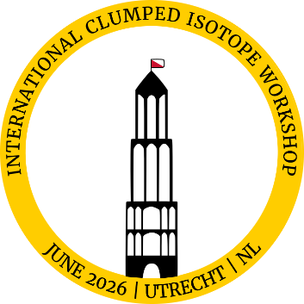
Figure 1: This is the style for figure captions. Make sure that the figure caption is on the same page as the figure itself and no more than 4 sentences.

